Published World Patent Application: WO2025008381
Title: SUBSTITUTED HEXAHYDRO-2H-PYRAZINO[1,2-A]PYRAZIN-1(6H)-ONE DERIVATIVES AS ACTIVATORS OF HUMAN CASEINOLYTIC PROTEASE P (HSCLPP)
List of Authors includes:
Andrea Abreu Garcia
Atteneri Chico Campos

Published at:
https://patentscope.wipo.int/search/en/detail.jsf?docId=WO2025008381&_cid=P22-M6J4QY-93779-1

This patent application is also published on these websites
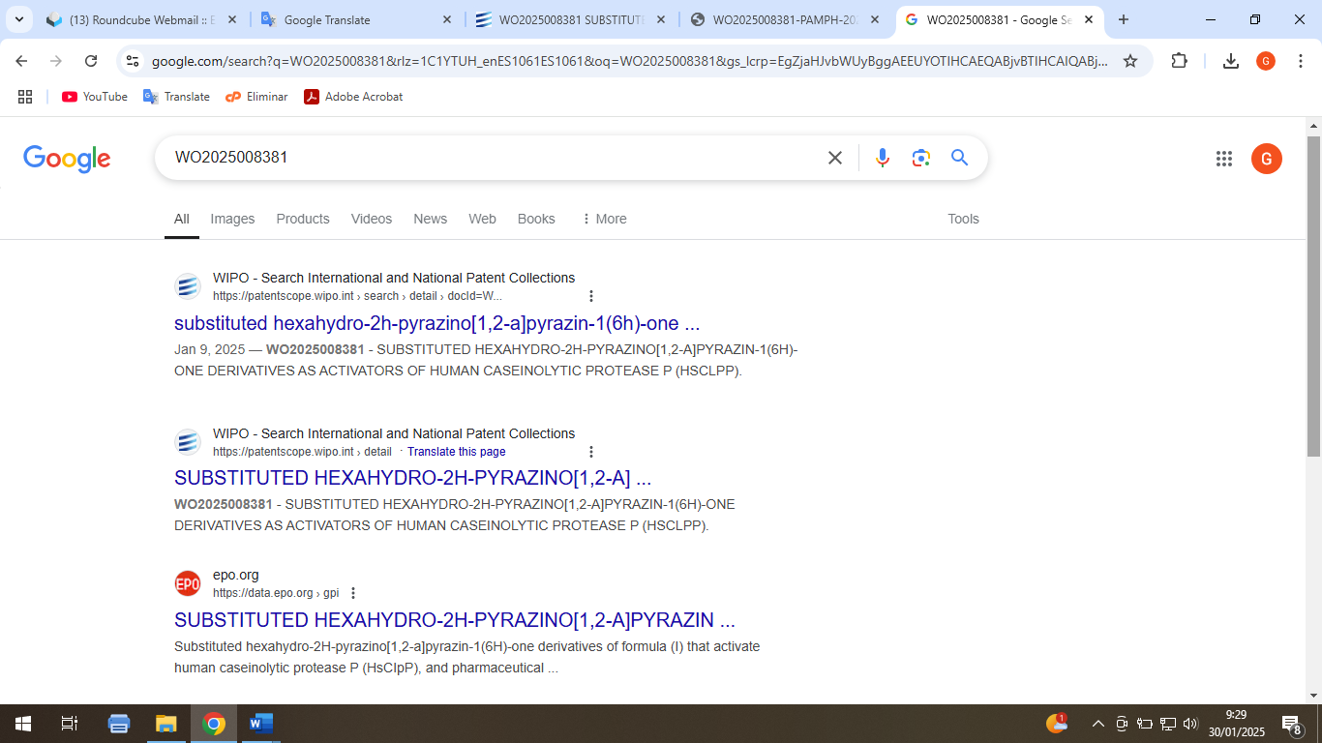

Front page of patent application WO 2025/008381
